**Everett Public Schools**

2013/2014

**Lowell Elementary School**

**Standard Emergency Operation Procedures**

**Foster, Cindy**

**Revised 7/08/13**

**Lowell Emergency Procedures**

**2013-2014**

# Earthquake & Evacuation Instructions

##### Earthquake Procedures

**Before it Hits!**

1. Be aware of room hazards. (windows, light fixtures, bottles, chemicals)
2. Is heavy equipment properly secured down?
3. What about rooms with gas lines? Do you know where the shut-off valves are?

##### Classroom Procedures

1. Stay calm; your students are depending on you! Get under a desk if possible.
2. Drop to your knees with your back towards any windows.
3. Clasp your hands behind your neck.
4. If directed to evacuate, follow the evacuation plan as detailed on pages 2 & 3.

##### School Administrative Procedures

1. When appropriate signal evacuation of building by sounding alarm.
2. Assess damage and determine if any part of the school can be used as a shelter.
3. Activate school based ***emergency response teams***.

##### General Procedures for Evacuation

Teachers will lead students to the field using the evacuation routes as detailed on the “**Evacuation Routes**” map in your emergency backpack. (Also see page three for a copy of the map)

Always Assemble with your homeroom class

In all circumstances, students will assemble with their homeroom class. If you have a student(s) who are passing in the halls during an evacuation, take the student(s) with you and then once out on the field have them find their homeroom teacher.

##### Lunch or Passing Time

In the event that an alarm sounds during passing time, lunch, or any time that students are not with a teacher, they are to leave through the nearest exit and proceed to the assembly location. They will then locate their homeroom teacher.

##### During an Alarm (including fire drills)

* Teachers will bring their emergency backpacks and in this backpack there should be a current class list.
* Make sure no one is left in the classroom, turn lights off, and close and lock the door. Post your red/green sign in the door (green= ok, red= not ok, a student is hurt in the room, do not post a sign during a lockdown).
* Teachers are to lead their classes to the assembly location in silence. If needed, students will then be released to locate their homeroom teachers and attendance will be taken.
* The principal or designee will come to your location for attendance records. You need to complete the attendance sheet found in your backpack. Have that completed and ready to hand off when the designee comes to your location.
* Students are to remain quiet during entire event.
* When all is clear, the principal or designee will release classrooms back into the school.
* If we are unable to reenter the building, listen for further instructions from the principal or designee.

##### Parent / Child Reunification Process (if necessary)

If it is not safe to reenter the building, students will be walked to the Everett Golf and Country Club on 52nd and Colby where police will maintain a containment area. Students should be kept in single file lines with their homeroom class. (Police will shut down streets to allow for a safe crossing) The Parent / Child Reunification Team will handle reconnecting families -- See page 5 for more details.

# Evacuation Routes

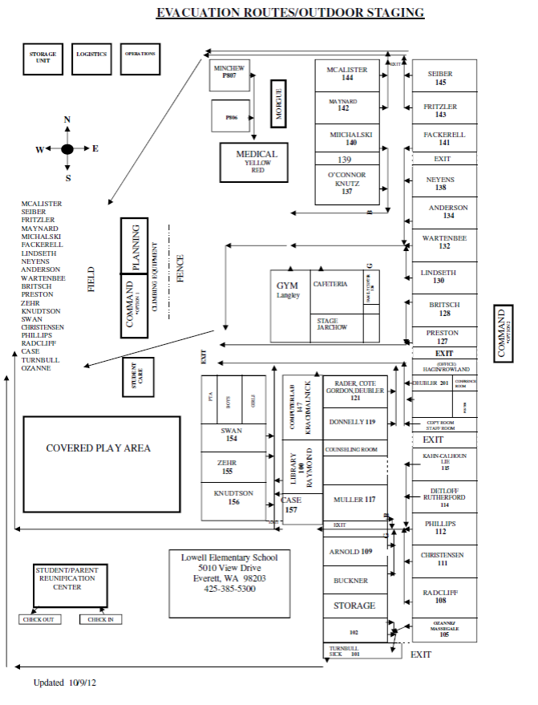

Evacuation Plan Maps

Revised 5/8/13

**SEE BELOW**

School Map

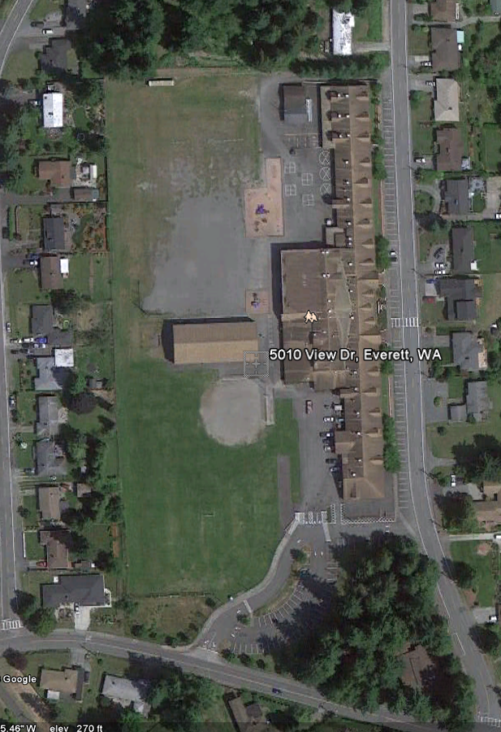

Evacuation Lines

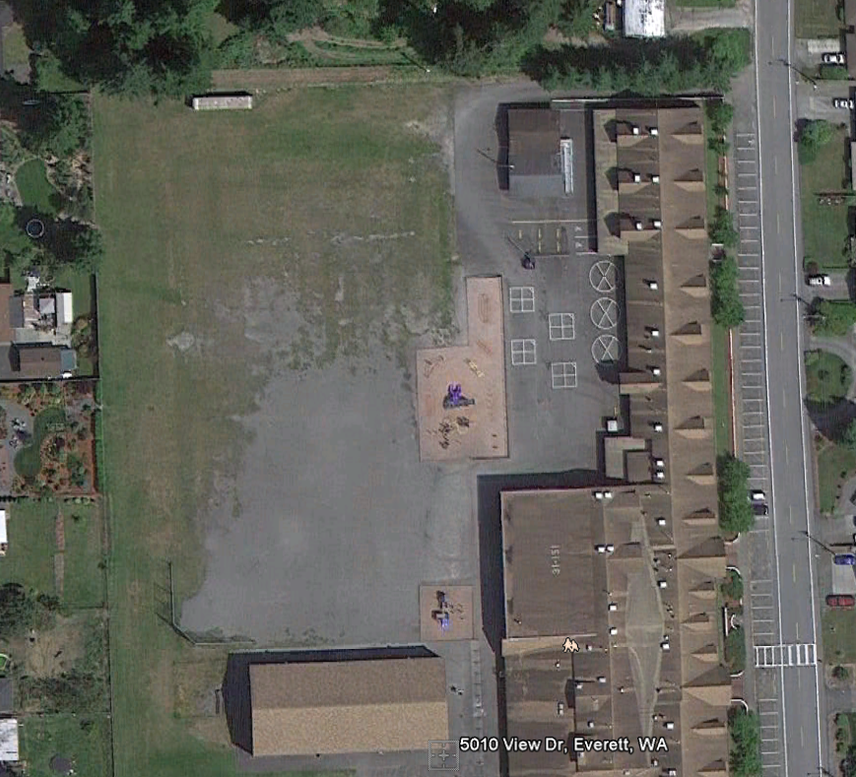

143

145

144

142

140

141

130

138

134

132

128

127

156

154

155

157

111

112

108

105

101

Evacuation Routes to Everett Golf and Country Club

1500 52nd St SE Everett, WA 98203  
(425) 259-8141

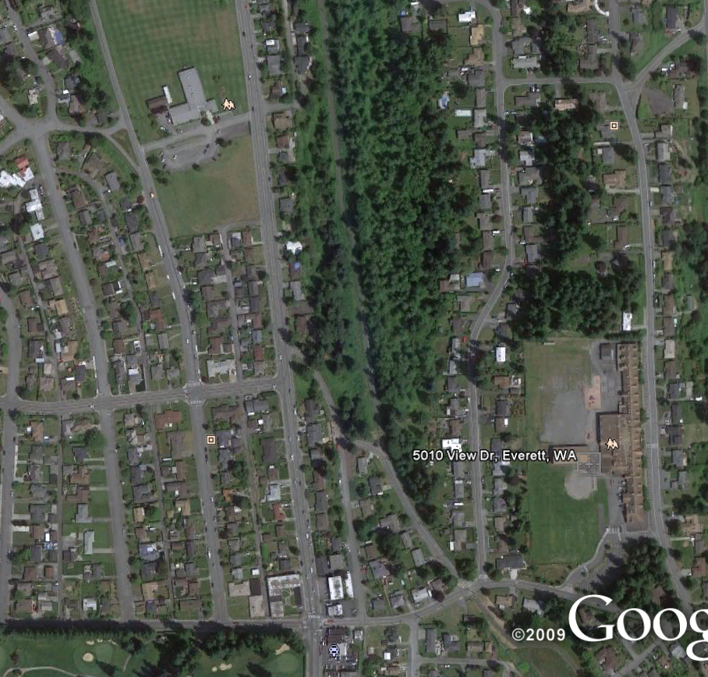

Everett Golf and Country Club Map

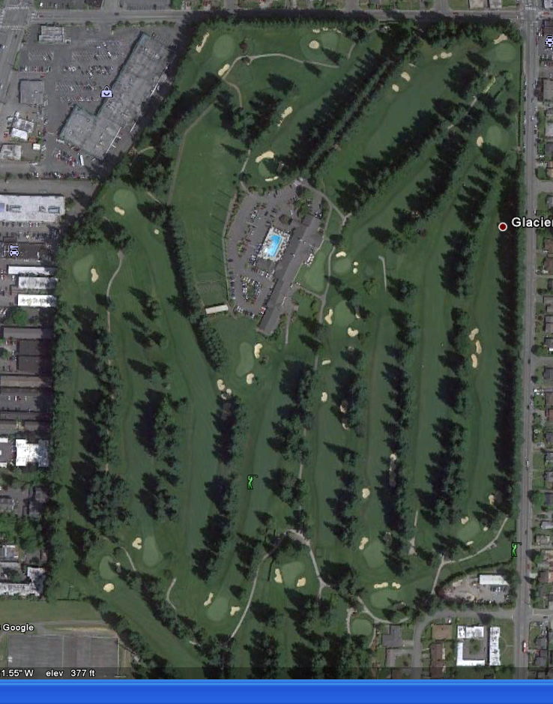

Everett Golf and Country Club Line Up Assignments

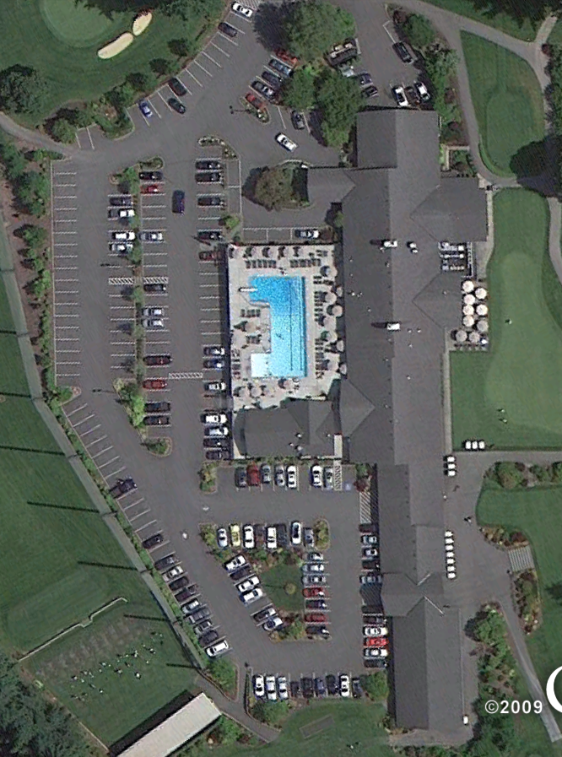

Everett Golf and Country Club Line Up Detailed

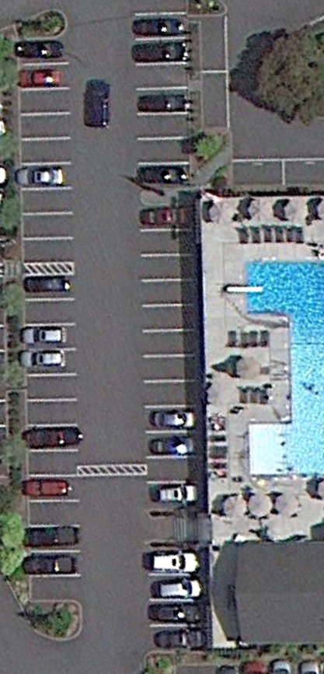

127

156

154

155

157

111

112

108

105

101

143

145

144

142

140

141

130

138

134

132

128

# 

# Lockdown Plan 2013-2014

##### Lockdown Announcement

* Any staff member who observes someone **DISPLAYING A FIREARM** or holding a **KNIFE** in a threatening manner you need to secure your room, call 911 and then you are authorized to make the following announcement. **“Your attention please! Staff, we are in a total red lockdown.”** **Dial *\*0107 then push #00* to access the intercom** (Make the announcement twice to make sure everyone has heard it). After making the announcement (if you can), call the school office at ext. 5301 or 5303 and give additional details.

##### Classrooms Instructions

1. Get the attention of the students, demand silence, and give calm, clear instructions.
2. Lock all doors (push / pull to make sure the door is fully latched) and turn off lights.
3. Cover all windows including the window in the door. Move students away from doors and windows.
4. Once the lockdown is in place, do not open the door (see classroom evacuations for exceptions to this).
5. If the fire alarm sounds *during a lockdown* **do not evacuate!!** (the alarm could have been pulled by the intruder or as a result of smoke from gunfire and/or explosions). Only evacuate if actual flames are observed. All evacuations will be done on a room by room basis.
6. As you lock doors, check hall for any isolated students who need to enter. Any stray students become your responsibility. Turn off lights, close blinds, settle students away from doors and windows. Take attendance. ***We agreed not to unlock the doors to any late-comer students or adults.***
7. Then send one (1) complete email to **LOE.MailList. It is either “All OK”** or **“Please read.” Nothing else. Include anything out of the ordinary in the message area of the email.** There is no need to put your name in the subject of the email since we can see who it is from. Office staff will access email and verify location and safety of all students and staff. When deemed safe, an email will be sent on LOE.MailList from the office to indicate updates of the situation to the best of our knowledge.
8. If you and **all the students assigned to you** at that time are present and safe, write in the SUBJECT LINE “All OK”. No teacher name is necessary. You do not need to write a message. Anything out of the ordinary needs a “Please Read” message. ORDINARY means teacher and all students in their homeroom. Not one student is absent.
9. If you have **absent students,** send only the “Please Read” message with the students listed who are absent. Do not send an All OK and then a second one with absent students.
10. If you are **missing some students** who are at school and are assigned to you, or have students **who are seriously hurt**, write in the SUBJECT LINE “Please Read”. In the message, write the full names of students missing and where you think they are, or the full names of injured students.
11. If you are a **specialist and have students**, write in the SUBJECT LINE “Please Read” then in the message write whose class or individual students who are with you. Also list any missing, absent, unaccounted for, or extra student and adult names (any unordinary situation).
12. If you have **extra** **students who are not yours** **or extra adults**, (skills groups) adults, volunteers, parents, paras, this should be in the only email: in the SUBJECT LINE “Please Read” and list the full names of the students and last name of their teachers (Jorge Fernandez, Swan)
13. If you are in a **planning period** and your children are at a specialist, send a “Please Read” and note where you are, if anyone else is with you and where your students should be, **including if you have a student(s) in resource, nurse, OT, SLP, psych, counselor, etc.**
14. If you are by yourself, **(You are specialist, counselor, RR.—not someone in planning) have** **no students or other adults with you at that time and your are in your room or office**, write in the SUBJECT LINE only “All OK.” If anyone else is with you—it’s a “Please Read” message.
15. If you do not have access to email, account for the students you have with you. There are only a few places in the building that do not have email access, and office staff will verify your location as soon as we can.
16. Do not use the phone. The noise could give away your location.
17. Unless you were the one to announce a total red lockdown, do not call 911 unless you have students who are seriously injured or you have information about the intruder. We need to leave the lines open.
18. Instruct students that **NO student may make a call or text a message** with a cell phone.

This may cause undue panic for parents and perhaps bring them to school, complicating the safety of everyone. Police and the district will make all public announcements. Adult helpers in classrooms must follow same procedures—including cell phones.

**Outside lockdown procedures:**

**Playground**: If the problem is inside the building, students who are outside will NOT be brought back in. Instead, they will be walked off to the south side of the playground behind the covered play area, or off to the north side of the playground behind the storage unit.

If the problem is outside the building, students should be escorted to closest safe entry door (probably center back doors or cafeteria doors) and proceed to gym or cafeteria to take cover. Homeroom teachers are asked, if safe, to come and be with your students.

When lockdown ends, an intercom announcement will be made from the office with the phrase: **ALL CLEAR. ALL CLEAR. (Note repetition—anything else is not the end of the lockdown).**

At that time, teachers should account for all their students and debrief with students to clarify what has happened.

**Modified Lockdown Procedures (Yellow):**

A modified lockdown is when the threat is outside the building and all we need to do is lock outside doors, close blinds, and keep kids inside the building. Still do email accounting of students.

Moving about from room to room may or may not be possible (such as bathroom trips or going to lunch) depending on the type of threat. Office will let you know via email if restrooms are ok.

If this happens, we will follow this procedure:

* + Announcement over intercom of **Modified Yellow Lockdown** with clarification if necessary.
  + Collect all students into your room. Do not allow students to go to bathroom unless it is made clear that it is OK.
  + Close blinds and instruct students of safety measures (stay in seat, partner voice, away from windows, etc.).
  + **Follow email procedure as above to account for yourself and students.**
  + **The intercom is heard outside so any further messages will be sent from the office over email.**

**The difference on Modified Lockdown is:**

* + Carry on with normal instruction, or read to students, have students read silently, or draw.
  + Students in portable classrooms must stay there until all clear is given.
  + Restrooms may or may not be available within building. Wait for clarification on this.

When lockdown is clear, an intercom announcement will be made from the office with the phrase: **ALL CLEAR. ALL CLEAR (note the repetition).**

**More information:**

* Office emails will have a red exclamation mark and be from Wayne, Dave D, Mary R. or Cindy.
* Students who are not in a room when the doors are locked should find the closest safest (out of sight) location such as the office, a restroom, storeroom.
* Do not to open the door, even for a child, once you lock it.
* Yes, report absent students in a “Please read” message. (Do not send an ALL OK msg in that case.) Because, what if a student arrives late, signs in at the office but doesn’t make it to your room? We need to know that student hasn’t made it to you.
* Please don’t sit and read all emails; your responsibility is your students in your classroom.
* Be efficient: Don’t open the “ALL OK” emails from other teachers but if you are missing kids, you might find out where they are by reading the “Please read” messages.
* It is always a good daily practice to account for all students after specials and recess.
* It is necessary if you don’t have all your students to send a “Please read” message to say Johnny Jones should be in Resource Room or Pam Smith was sent to the health room at recess.
* Names on desks help subs in this situation.
* Rotation classes: It is helpful if you identify the teacher whose homeroom you have and essential to tell us who isn’t there.
* **Specialists** will report “ALL OK with teacher name” in subject box if 100% of class is present OR
* **Specialists** will send “Please Read” email to report which class they have and who is absent.
* **We still have no solution to the guest teacher’s no email or no room key problem. However, a work order for room keys for subs has been submitted on 12/20/12.**
* **Try to remember if you have a guest teacher next door, call them (one time it’s ok to use phone) to see if all O.K. and send “Please Read” email to the office for them.**
* **Please brainstorm and rehearse with your students how to get out of the bathroom immediately if they hear there is a lockdown: don’t flush, don’t wash, go immediately to closest classroom. Brainstorm where that might be from your location or restrooms near specialists.**
* **Assigned staff will be expected to lock (or check lock) the exterior door closest to their rooms.**

Doors that need to be locked in a lockdown and shades pulled:

* + North facing 3rd grade door (Seiber, backup Fritzler)
  + South facing 4th grade door. (Knudtson, backup Zehr)
  + Three west facing doors (5th grade (Phillips, backup Radcliff), gym hall (Langley, backup

Swan), and 1st grade doors (Wartenbee, backup Lindseth)

* + Main Entry (Wayne, backup Mary R)

Doors that are always locked are all three east facing doors and should be checked, and

shade pulled by the following:

* + By the Counselor’s office (Calhoun, backup Donnelly)
  + By 3rd grade (Michalski, backup Maynard)
* **Custodian will no longer sweep building for all doors. Custodian will sweep building to lock doors where subs are located (this is until we have keys for our subs).**

##### Gym Class

* All students will be secured in the gym office. If you are outside for PE do not come back in.

**Passing Time**

* **Teachers** will go into the halls and begin flagging any and all students into their rooms. Then follow all instructions for classrooms.

##### Cafeteria During Lunch

1. **Staff** in the lounge (during lunch) will proceed to the cafeteria to assist with students, if it safe to do so.
2. **Lunch Staff** in the cafeteria will direct students to a corner of the cafeteria or to exit out the cafeteria doors. Cafeteria staff will lock the cafeteria doors.
3. **Radar** will notify the P.E. classes.
4. **Lunch outside staff** will follow these procedures -- Students that are outside during lunch will be led to behind the covered area or behind the storage container.

**Parent / Child Reunification**

If students need to be evacuated they will be taken by foot via the designated route to the Everett Golf and Country Club on 52nd and Colby.

##### Route of travel to off-campus site

* Teachers/Staff will maintain students in their orderly lines and lead them to the Everett Golf and Country Club on 52nd and Colby
* The direction of travel will be (see evacuation maps above).

##### After the Event

* Resume normal operations as soon as possible.
* Assess the need for aftercare, counseling, or Critical Incident Stress Debriefing.
* Email staff an overview of the incident to minimize misinformation.
* Notify district when the incident is concluded. Contact the PIO to prepare a letter to parents.
* Debrief & evaluate with key staff, including first responders.
* Prepare a report that documents the events, response, and results of the lockdown. Revise response procedures as necessary. Enter changes in Rapid Responder.

# 

# Incident Response Chart

Incident response chart is attached to this plan. It is also located in each staff members red emergency folder. This chart communicates job assignments during an incident.

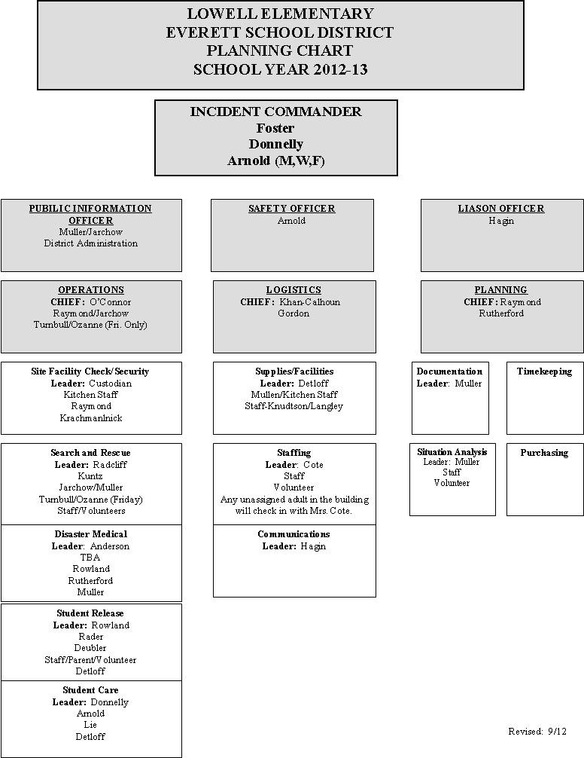

# Overview of Emergency Team Personnel

School Command Post – Established in cafeteria or out on field.

Incident Commanders – **Cindy Foster or Mary Donnelly, Robin Arnold**

**Site Facility Check / Security / Sweep Team**

* If possible the **Sweep Team** will ensure that the building is fully evacuated.

##### Search & Rescue Team

* Rescue gear is stored in the emergency supply container out in the field.
* The Rescue gear will consist of: stretchers, sledge hammers, pry bars, gloves, & flashlights.

##### Medical Team

* The medical team will establish a “triage” in__________. If more space is needed they may also use__________.
* Medical supplies will be brought up from the emergency supply locker.
* In addition to the established **Medical Teams** the following personnel are First Aid certified: _____________________

##### Student Release

**Additional staff will be assigned as needed by the Command Post.** Para-Educators will be used as runners. The following is a list of needs and procedures:

* Each team will have a full set of class lists/student lists. Each team will divide the lists into three alphabetical groups. The class lists/student lists could be used as a means of tracking the status of each student by writing directly on them.
* Other options are to use the Student Release Form or to have a preprinted list of student names and have the parent/guardian and school representative sign next to the student’s name. Also include the date and time.
* Daily attendance records to determine who is absent or signed out early.

##### Staff Care Team

* Responsibilities consist of personally checking the welfare of every staff member.
* They will have a list of staff members, a notepad and a pen.
* They will report any issues to the Command Post

# Incident Flow for Natural Disaster

The following is an ***example*** of how the school staff would respond in the event of a situation that renders the building unusable. (This plan is NOT for lockdowns)

1. *Classroom Teachers* comprise the **Student Care Team** and will stay with their students at all times following the established plan to evacuate building when instructed to do so. Absolute silence is required. Attendance will be taken and submitted once out on the field.
2. **The Sweep Team** will clear the building and report the condition of the facility to the Command Post.
3. **The Command Post** will be established in __________. Any staff member who does not have an assignment will report to the command post.
4. If students are unaccounted for, information will be gathered as to where they were last seen.
5. **Logistics Personnel** will go to the Emergency supply container and prepare to hand out supplies.
6. **Rescue Team** members (*Same as sweep team*) will retrieve their gear from the emergency supply locker and look for the missing students.
7. The **Medical Team** will retrieve their supplies from the emergency supply locker and establish a medical post in _________. The Command Post will assign additional help as needed.
8. If the decision is made NOT to reenter the building the students will remain on the field with their homeroom teachers. The **Student Release Team** will gather supplies from the container and establish a post in the field.
9. **Staff Care Team** – Assigned staff person will contact every member to check their welfare.
10. On the hour and the half hour each **Team Leader** will report in person or by radio to the **School Command Post** to update their situation. This information will be recorded by the **Planning / Intelligence** **Chief**.
11. **Available Staff Members** -- These staff members do not have students and can be used to supplement the Medical Team, Student Release Team or to be a runner: ______________.The kitchen staff may also be available.

# Incident Commander – School Command Post

|  |  |
| --- | --- |
| Responsibilities | The Incident Commander is solely responsible for emergency/disaster operations and shall remain at the Command Post to observe and direct all operations.  Ensure the safety of students, staff, and others on campus. Lead by example: your behavior sets tone for staff and students. |
| Start-up Actions: | * Obtain your personal safety equipment if available (i.e., hard hat, vest, clipboard with job description sheet). * Assess the type and scope of emergency. * Determine the threat to human life and structures. * Implement the emergency plan and hazard-specific procedures. * Develop and communicate an incident action plan with objectives and a timeframe to meet those objectives. * Activate functions and assign positions as needed. * Fill in the Incident Assignments form. * Appoint a backup or alternate Incident Commander |
| OngoingOperationalDuties: | * Continue to monitor and assess the total school situation: * View the site map periodically for search and rescue progress and damage assessment information. * Check with chiefs for periodic updates. * Reassign personnel as needed. * Develop and communicate revised incident action plans as needed. * Begin student release when appropriate. * NOTE: No student should be released until student accounting is complete. Never send students home before the end of the regular school day unless directed by the principal/superintendent, except at the request of parent/guardian. * Authorize the release of information. * Utilize your backup; plan and take regular breaks (5-10 minutes per hour). During break periods, relocate away from the Command Post. * Plan regular breaks for all staff and volunteers. Take care of your caregivers! * Release teachers as appropriate and per school guidelines. (By law, during a disaster, teachers become disaster workers.) * Remain on and in charge of your campus until redirected or released by the superintendent. |
| Closing Down: | * Authorize deactivation of sections when they are no longer required. * At the direction of the principal/Superintendent, deactivate the entire emergency response. If the fire department or other outside agency calls an “all clear,” contact the district before taking any further action. * Ensure the return of all equipment and reusable supplies to Logistics. * Close out all logs. Ensure that all logs, reports, and other relevant documents are completed and provided to the Documentation Unit. |
| Command PostEquipment/Supplies: | * Campus map * LED Flashlight * Master keys * Staff and student rosters * Tables and chairs * Job description clipboards * Clip boards, spiral note books, pens, pencils, markers * Campus two-way radios * AM/FM/ NOAA Weather Alert Radio (batteries) * Bullhorn |

# Safety Officer

|  |  |
| --- | --- |
| Responsibilities | The Safety Officer ensures that all activities are conducted in as safe a manner as possible under the existing circumstances. |
| Start-Up Actions: | * Check in with the Incident Commander for a situation briefing. * Obtain necessary equipment and supplies from Logistics. * Put on a position identifier, such as a vest, if available. * Open and maintain a position log. Maintain all required records and documentation to support the history of the emergency or disaster. Document: * Messages received. * Action taken. * Decision justification and documentation. * Requests filled. |
| Operational Duties: | * Monitor drills, exercises, and emergency response activities for safety. * Identify and mitigate safety hazards and situations. * Stop or modify all unsafe operations. * Ensure that responders use appropriate safety equipment. * Think ahead and anticipate situations and problems before they occur. * Anticipate situation changes, such as cascading events, in all planning. * Keep the Incident Commander advised of your status and activity and on any problem areas that now need or will require solutions. |
| Closing Down: | * When authorized by the Incident Commander, deactivate the unit and close out all logs. Provide logs and other relevant documents to the Documentation Unit. * Return equipment and reusable supplies to Logistics. |
| Equipment/Supplies: | * Vest or position identifier, if available * Hard hat, if available * LED Flashlight * Clipboard, paper, pens * Two-way radio, if available |

# Public Information Officer (PIO)

|  |  |
| --- | --- |
| Personnel: | Available staff with assistance from available volunteers |
| Policy: | The public has the right and need to know important information related to an emergency/disaster at the school site ***as soon as it is available.***  The PIO acts as the official spokesperson for the school site in an emergency situation.  News media can play a key role in assisting the school in getting emergency/ disaster-related information to the public (parents). Information released must be consistent, accurate, and timely. |
| Start-Up Actions: | * Determine a possible “news center” site as a media reception area (located away from the Command Post and students). Get approval from the Incident Commander. * Identify yourself as the PIO (by vest, visor, sign, etc.) * Consult with the district PIO to coordinate information release. * Assess the situation and obtain a statement from the Incident Commander. Tape-record the statement if possible. * Advise arriving media that the site is preparing a press release and the approximate time of its issue. * Open and maintain a position log of your actions and all communications. If possible, tape media briefings. Keep all documentation to support the history of the event. |
| Operational Duties: | * Keep up to date on the situation. * Statements must be approved by the Incident Commander and should reflect: * Reassurance (EGBOK— “Everything’s going to be OK.”) * Incident or disaster cause and time of origin. * Size and scope of the incident. * Current situation—condition of school site, evacuation progress, care being given, injuries, student release location, etc. Do not release any names. * Resources in use. * Best routes to the school, if known and if appropriate. * Any information the school wishes to be released to the public. |

#### Public Information Officer (PIO) (Continued)

|  |  |
| --- | --- |
|  | * **Read** statements if possible. * When answering questions, be complete and truthful, always considering confidentiality and emotional impact. Avoid speculation, bluffing, lying, talking “off the record,” arguing, etc. Avoid using the phrase “no comment.” * Remind school staff and volunteers to refer *all* questions from the media or waiting parents to the PIO. * Update information periodically with the Incident Commander. * Ensure that announcements and other information are translated into other languages as needed. * Monitor news broadcasts about the incident. Correct any misinformation heard. |
| Closing Down: | * At the Incident Commander’s direction, release PIO staff when they are no longer needed. Direct staff members to sign out through Timekeeping. * Return equipment and reusable supplies to Logistics. * Close out all logs. Provide logs and other relevant documents to the Documentation Unit. |
| Equipment/Supplies: | * Public information kit consists of: * ID vest * Battery-operated AM/FM radio * LED Flashlight * NOAA Weather Radio * Paper/pencils/marking pens * Scotch tape/masking tape * Scissors * School site map(s) and area maps   • 8-l/2 x 11 handouts  • Laminated poster board size for display   * Forms: * Disaster Public Information Release Work Sheet * Sample Public Information Release * School Profile or School Accountability Report Card (SARC) |

# Liaison Officer

|  |  |
| --- | --- |
| Responsibilities | The Liaison Officer serves as the point of contact for agency representatives from assisting organizations and agencies outside the school and assists in coordinating the efforts of these outside agencies by ensuring the proper flow of information. |
| Start-Up Actions: | * Check in with the Incident Commander for a situation briefing. * Determine your personal operating location and set it up as necessary. * Obtain the necessary equipment and supplies from Logistics. * Put on a position identifier, such as a vest, if available. * Open and maintain a position log. Maintain all required records and documentation to support the history of the emergency or disaster. |
| Operational Duties: | * Brief agency representatives on the current situation, priorities, and incident action plan. * Ensure coordination of efforts by keeping the Incident Commander informed of agencies’ action plans. * Provide periodic update briefings to agency representatives as necessary. |
| Closing Down: | * At the Incident Commander’s direction, deactivate the Liaison Officer position and release staff no longer needed. Direct staff members to sign out through Timekeeping. * Return equipment and reusable supplies to Logistics. * Close out all logs. Provide logs and other relevant documents to the Documentation Unit. |
| Equipment/Supplies: | * Vest or position identifier, if available * Two-way radio, if available * LED Flashlight * Clipboard, paper, pens |

# Operations Section Chief

|  |  |
| --- | --- |
| Responsibilities | The Operations Chief manages the direct response to the disaster, which can include:   * Site Facility Check / Security * Search and Rescue * Medical * Student Care and Student Release |
| Start-Up Actions: | * Check in with the Incident Commander for a situation briefing. * Obtain necessary equipment and supplies from Logistics. * Put on a position identifier, such as a vest, if available. |
| Operational Duties: | * Assume the duties of all operations positions until staff are available. * As staff members are assigned, brief them on the situation, and supervise their activities, using the position checklists. * If additional supplies or staff is needed for the Operations Section, notify the Incident Commander. When additional staff arrives, brief them on the situation, and assign them as needed. * Deploy the search and rescue team if needed. * As information is received from operations staff, pass it on to Planning Chief to be recorded for “situation analysis” and / or the Incident Commander. * Ensure that operations staff is following standard procedures, using appropriate safety gear, and documenting their activities. * Schedule breaks and reassign staff within the section as needed. |
| Closing Down: | * At the Incident Commander’s direction, release Operations staff no longer needed. Direct staff members to sign out through Timekeeping. * Return equipment and reusable supplies to Logistics. * When authorized by the Incident Commander, deactivate the section and close out all logs. Provide logs and other relevant documents to the Documentation Unit. |
| Equipment/Supplies: | * Vest or position identifier, if available * Search & Rescue equipment * Two-way radio / NOAA Weather Radio * LED Flashlight * Job description clipboard, paper, pens * Maps: Search and rescue maps & large campus map |

# Site Facility Check / Security / Sweep Team

|  |  |
| --- | --- |
| Personnel: | Staff as assigned. |
| Responsibilities: | Take no action that will endanger you. |
| Start Up Actions: | * Wear hard hat and orange identification vest, if available. * Take appropriate tools, job description clipboard, and radio. * Put batteries in flashlight if necessary. |
| Operational duties: | As you complete the following tasks, observe the campus and report any damage by radio to the Command Post.   * **Remember:** If you are not acknowledged, you have not been heard. Repeat your transmission, being aware of other simultaneous transmissions. * Lock gates and major external doors. * Locate, control and extinguish small fires as necessary. * Check gas meter and, *if gas is leaking,* shut down the gas supply. * Shut down electricity only if building has clear structural damage or advised to do so by Command Post. * Post yellow caution tape around damaged or hazardous areas. * Verify that the campus is “locked down.” * Advise the Command Post of all actions taken for proper logging. * Check entire campus for safety hazards and damage. * No damage should be repaired before full documentation, such as photographs and video evidence, is complete unless the repairs are essential to immediate life-safety. * Route fire, rescue, and police, as appropriate. |
| Closing Down: | * Return equipment and reusable supplies to Logistics. * When authorized by the Incident Commander, close out all logs. Provide logs and other relevant documents to the Documentation Unit. |
| Equipment/Supplies: | * Vest, hard hat, work gloves, and whistle. * LED Flashlight * NOAA Weather Radio * Campus two-way radio, master keys, and clipboard with job description. * Bucket or duffel bag with goggles, flashlight, dust masks, yellow caution tape, and shutoff tools—for gas and water (crescent wrench) |

# Search and Rescue Team

|  |  |
| --- | --- |
| Safety Rules: | Assign a minimum of 3 persons to each team.  Take no action that might endanger you. Do not work beyond your expertise. Use appropriate safety gear. Size up the situation first. **Follow all operational and safety procedures.** |
| Start-up Actions: | * Obtain all necessary equipment from Emergency Storage Container. * Obtain a briefing from Operations Chief of situations requiring response. * Assign teams based on available manpower, minimum 3 persons per team. |
| Operational Duties: | * Perform a visual and radio check of the outfitted team. * Record names and assignments before deploying teams. * Dispatch teams to known hazards or situations first, then to search the campus using specific planned routes. * If injured students are located, consult the Operations Section Chief for response. Utilize Transport teams, or send a First Aid Team. |
| Operational Duties: | * Before entering a building, inspect the complete exterior of the building. Report structural damage to the team leader. Use yellow caution tape to barricade hazardous areas. Do not enter severely damaged buildings. If you are in doubt about your safety, DO NOT ENTER! * If the building is safe to enter, search the assigned area (following the map) using an orderly pattern. Check all rooms. Use chalk or grease pencil to mark a slash on the door when entering a room. Check under desks and tables. Search visually and vocally. Listen. When leaving each room, complete the slash to form an “X” on the door. Report by radio to the Command Post that the room has been cleared (e.g. “Room 123 is clear.”). * When an injured victim is located, transmit the location, number, and condition of the injured to the Command Post. Do not use names of students or staff. Follow directions from the Command Post. * Keep radio communication brief and simple. Do not use codes. |
| Closing Down: **Supplies**: | * Record the return of each S&R team. Direct them to return equipment and report to Logistics for additional assignment. * Provide maps and logs to the Documentation Unit. * Vest, hard hat, work and latex gloves, and whistle with master keys on lanyard. One team member should wear a first aid backpack. * Campus two-way radio and clipboard with job description and map indicating the search plan. * Bucket or duffel bag containing goggles, flashlight, dust masks, pry bar, grease pencil, pencils, duct tape, and masking tape. |

# Medical Team

|  |  |
| --- | --- |
| Responsibilities | The Medical Team Leader is responsible for providing emergency medical response, first aid, and counseling. He or she informs the Operations Chief or Incident Commander when the situation requires health or medical services that staff cannot provide. |
| Operational Duties:Start-Up Actions: | * Establish scope of disaster with the Incident Commander and determine probability of outside emergency medical support and transport needs. * Make personnel assignments. If possible, assign a minimum of two people to triage, two to immediate treatment, two to delayed treatment, and two to psychological treatment. * Set up a first aid area in a safe place (upwind from the emergency area if the emergency involves smoke or hazardous materials), away from students and parents, with access to emergency vehicles. Obtain equipment and supplies from the storage area. * Assess available inventory of supplies and equipment. * Oversee the assessment, care, and treatment of patients. * Ensure caregiver and rescuer safety: Ensure that they use latex gloves for protection from body fluids and new gloves for each new patient. * Make sure that accurate records are kept. * Provide personnel to respond to injuries in remote locations or request a Transport Team from Logistics. * If needed, request additional personnel from Logistics. * Keep the Operations Section Chief informed of the overall status. * Stay alert for communicable diseases and isolate appropriately. |
| Closing Down: | * At the Incident Commander’s direction, release medical staff no longer needed. Direct staff members to sign out through timekeeping. * Return equipment and reusable supplies to Logistics. * When authorized by the Incident Commander, deactivate the section and close out all logs. Provide the logs and other relevant documents to the Documentation Unit. |
| Equipment/Supplies: | * First aid supplies. (See the list on the following page.) * LED Flashlight & NOAA Weather Radio * Stretchers * Tables and chairs * Staff and student medication from the Health Office * Forms: Notice of First Aid Care & Medical Treatment Victim Log * Masking tape, Marking pens, Blankets * Quick reference medical guides, Ground cover/tarps |

#### Medical Team (Continued)

|  |
| --- |
| Recommended First Aid Supplies:   * 4 x 4" compress: 1000 per 500 students * 8 x 10" compress: 150 per 500 students * Kerlix bandaging: 1 per student * Ace wrap: 2-inch: 12 per campus   4-inch: 12 per campus   * Triangular bandage: 24 per campus * Cardboard splints: 24 each of sm, med, lg. * Steri-strips or butterfly bandages: 50 per campus * Aqua-Blox (water) cases (for flushing wounds, etc.): 0.016 x students + staff = # cases * Neosporin: 144 squeeze packs per campus * Hydrogen peroxide: 10 pints per campus * Bleach: 1 small bottle * Plastic basket or wire basket stretchers or backboards: 1.5 per 100 students * Scissors, paramedic: 4 per campus * Tweezers: 3 assorted per campus * Triage tags: 50 per 500 students * Latex gloves: 100 per 500 students * Oval eye patch: 50 per campus * Tapes: 1" cloth: 50 rolls/campus   2" cloth: 24 per campus   * Dust masks: 25 per 100 students * Disposable blanket: 10 per 100 students * First Aid Books: 2 standard and 2 advanced per campus * Space blankets: 1 per student and staff * Heavy duty rubber gloves: 4 pair |

# Medical Branch Morgue

|  |  |
| --- | --- |
| Personnel: | To be assigned by the Operations Section Chief if needed. |
| Start-Up Actions: | * Check with the Operations Section Chief for direction. * If directed, set up a morgue area. Verify: * Tile, concrete, or other cool floor surface * Accessible to Coroner’s vehicle * Remote from the assembly area * Security: Keep unauthorized persons out of the morgue. * Maintain a respectful attitude. |
| Operational Duties: | After pronouncement or determination of death:   * ***Confirm that the person is actually dead. Remember, you do not have the authority to pronounce a person dead. This must be done by the Coroner or other medical authority.*** * ***Do not*** move the body until directed by the Command Post. * ***Do not*** remove any personal effects from the body. Personal effects must remain with the body ***at all times.*** * As soon as possible, ***notify the Operations Section Chief,*** who will notify the Incident Commander, who will attempt to notify law enforcement authorities of the location and, if known, the identity of the body. Law enforcement personnel will notify the Coroner. * Keep accurate records and make them available to law enforcement and/or the Coroner when requested. * Write the following information on two tags: * Date and time found. * Exact location where found. * Name of decedent if known. * If identified—how, when, by whom. * Name of person filling out tag. * Attach one tag to body. * Place any additional personal belongings found in a separate container and label as above. Do not attach to the body—store separately near the body. |
| Closing Down: | * After all bodies have been picked up, close down the Morgue. * Return equipment and unused supplies to Logistics. * Clean up the area. Dispose of hazardous waste safely. * Complete all paperwork and turn in to the Documentation Unit. |
| Equipment/Supplies: | * Tags, LED Flashlight, NOAA Weather Radio * Pens/pencils, Plastic trash bags, Duct tape * Vicks VapoRub (to assist with odor), Plastic tarps, Stapler, 2" cloth tape |

# Student Release

|  |  |
| --- | --- |
| Personnel: | Staff as assigned by the school. |
| Responsibilities | Assure the reunification of students with their parents or authorized adult through Release Request and Release Gates. |
| Start-Up Actions: | * Check with the Operations for assignment to the Request Gate or Release Gate. * Obtain necessary equipment and forms from Logistics. * Secure the area against unauthorized access. Mark the gates with signs. * Set up the Request Gate at the main student access gate. Use alphabetical grouping signs to organize parent requests. * Have Student Release Forms available for parents outside of the fence at the Request Gate. Assign volunteers to assist. * Set up the Release Gate some distance from the Request Gate. |
| General Overview: | If it’s been determined after an emergency that our building will not be reentered the students will either locate their homeroom class on the play fields or be taken on foot to _______________. This could be the aftermath of a fire, earthquake or lockdown.  For Example:   * The building has been evacuated after a fire or earthquake and students have assumed their evacuation locations on the play fields and attendance is completed. * If it is determined that the students will be taken to the off-campus site, the students will stay with their homeroom teacher and walk in single file lines or be transported by bus to **the designated off-campus site.** * The exception to the above procedure would be an evacuation resulting from a lockdown incident in which students would not lineup on the fields but be taken directly to the off-campus site (the students will stay with the teacher and class that they were with when the incident began and attendance will be taken at the designated site). * The Student Release Team would then establish a post at the entrance to the designated off-campus site. Extra staff will be used to control exits and to keep students calm. |

# On-Campus Student Release Diagram

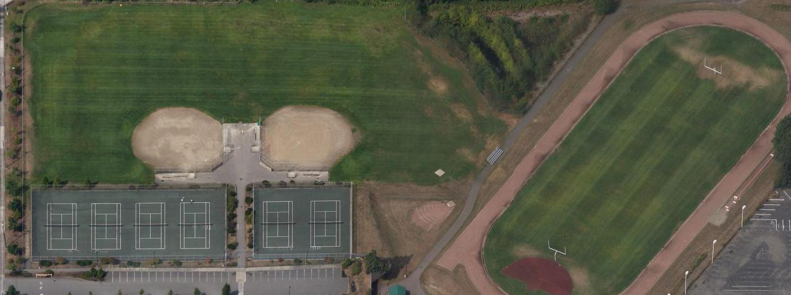This diagram illustrates release protocol from the field.

The student release teams will retrieve needed supplies from the emergency storage locker to begin the student release process. A security perimeter will be maintained to minimize egress of students and ingress of parents. The release point will be designated at the ___________. The ___________ can be used as the parent staging area.

Team 2

**Team 1** will be assigned to the ______.

**Team 2** will be assigned to the ______.

**Team 1** leader ________ – helpers: _______

**Team 2** leader ________ –helpers: ________

Para-Educators will be used as “runners”. The following is a list of needs and procedures:

* Each team will have a full set of locator cards. Each team will divide the cards into three alphabetical groups and place them in the binder. The locator cards should be used as a means of tracking the status of each student by writing directly on them.
* Other options are to use the *Student Release Form* or use a preprinted list of student names and have the parent/guardian and school representative sign next to the student’s name. Also include the date and time.

Team 1

# Off-Campus Release

Once an area is designated, the process is the same. The students will be assembled and lined up in their perspective _________ groups. The release point will be determined and set up far enough away from the student body to discourage intermingling and confusion of students and parents. If needed in a large crisis, vehicles may be needed to transport students to their parents for unification.

**N**

The **PIO** will use the media outlets to broadcast the reunification location for the parents.

Release Point

Beverly Lane

#### Student Release (continued)

|  |  |
| --- | --- |
| Specific Procedures: | * The requesting adult fills out a Student Release Form, gives it to a staff member, and shows identification. * The staff member verifies the identification and verifies that the requester is listed on the Emergency Locator Card. * The staff member instructs the requester to proceed to the Release Gate. * The runner takes the form(s) to the designated location. * Note: If a parent refuses to wait in line, don’t argue. Note the time with appropriate comments on the Emergency Card and place it in the out box. |
|  | **If the student is with the class:** |
|  | * Runner shows the Student Release Form to the teacher. * The teacher marks the box, “Sent with Runner.” * If appropriate, the teacher sends the parent copy of the First Aid Form with the runner. * The runner walks the student(s) to the Release Gate. * The runner hands the paperwork to release personnel. * Release Gate staff will match the student to the requester, verify proof of identification, ask the requester to fill out and sign the lower portion of Student Release Form, and release the student. Parents are given the Notice of First Aid Care Given, if applicable. |
|  | **If the student is not with the class:** |
|  | * The teacher makes the appropriate notation on the Student Release Form: * “Absent” if the student was never in school that day. * “First Aid” if the student is in the Medical Treatment area. * “Missing” if the student was in school but now cannot be located. * The runner takes Student Release Form to the Command Post. * The Command Post verifies the student’s location if known and directs the runner accordingly. * If the runner is retrieving multiple students and one or more are missing, the runner walks the available students to the Release Gate before returning “Missing” forms to the Command Post for verification. * The parent should be notified of the missing student’s status and escorted to a crisis counselor. * If the student is in First Aid, the parent should be escorted to the Medical Treatment Area. * If the student was marked absent, the parent will be notified by a staff member. |

#### Student Release (Continued)

|  |  |
| --- | --- |
| Closing Down: | * At the direction of the Operations Section Chief, return equipment and unused supplies to Logistics. * Complete all paperwork and turn it in to the Documentation Unit. |
| Equipment/Supplies: | * Binder with Emergency Locator cards for contacting parents. * Daily attendance records to determine who is absent or signed out early. * Student release forms for the ”runner” to use to sign out a student. * Pens, stapler * LED Flashlight * NOAA Weather Radio * Signs to mark Request Gate and Release Gate * Signs for alphabetical grouping to organize the parents (A-F, etc.) * Attendance sheets for every period of the day for every class. |

# Student Release Form

#### (To be taken by runner)

***Please print***

Student’s Name __________________________________________Grade ____________

Requested By: __________________________________________

## To be completed by Request Gate Staff

Proof of I.D._________________ Name on Disaster Release Form **(Yes)** **(No)**

Name of Staff Member _________________________

## To be completed by Student Care Staff (The teacher)

**Student’s Status**

Sent with Runner ________ Absent ________ First Aid _______ Missing _______

***(If student is absent, in first aid or missing - deliver this form to the Command Post)***

## To be completed by Release Gate Staff

Proof of I.D._____________________ Name on Disaster Release Form **(Yes) (No)**

(circle one)

### To be filled in by Requester At Release Gate

Requester Signature: __________________________________________________

Destination: __________________________________________________________

Date: _______________________________ Time: __________________________

# Logistics Section: Supplies & Facilities

|  |  |
| --- | --- |
| Responsibilities | The Logistics Section is responsible for providing facilities, services, personnel, equipment, and materials in support of the incident. |
| Start-Up Actions: | * Check in with the Incident Commander for a situation briefing. * Open the supplies container or other storage facility. * Put on position identifier, such as a vest, if available. * Begin distribution of supplies and equipment as needed. |
| Operational Duties: | * Coordinate supplies, equipment, and personnel needs. * Maintain security of the cargo container, supplies and equipment. |
| Closing Down: | * Close out all logs and secure all equipment and supplies. |
| Equipment/Supplies: | * Two-way radio, Job description clipboard, Paper, pens * Cargo container with all emergency supplies stored on campus * Clipboards with volunteer sign-in sheets |

# Planning Section Chief: Documentation

|  |  |
| --- | --- |
| Responsibilities | This section is responsible for the collection, evaluation, documentation and use of information about the development of the incident and the status of resources. |
| Start-Up Actions: | * Obtain necessary equipment and supplies if needed from Logistics. * Put on a position identifier, such as a vest, if available. |
| Operational Duties: | Records:   * Maintain a time log of the incident, noting all actions. * ***Important:*** A permanent log may be typed or rewritten at a later time for clarity and better understanding. Keep all original notes and records - **they are legal documents.** |
| Closing Down: | * Collect and file all paperwork and documentation from deactivating sections. * Securely package and store these documents for future use. * Return equipment and reusable supplies to Logistics. |
| Equipment/Supplies: | * Two-way radio, File box(es), Log books, paper, pens |

# Planning Section: Situation Analysis

|  |  |
| --- | --- |
| Responsibilities: | This section is responsible for the collection, evaluation, documentation and use of information about the development of the incident and the status of resources. Maintain accurate site map that will provide ongoing analysis of situation. |
| Start-Up Actions: | * Obtain necessary equipment and supplies from Logistics. |
| Operational Duties: | Situation Status (Map):   * Collect, organize and analyze situation information. * Mark the site map appropriately as related reports are received, including but not limited to S&R reports and damage updates. * Preserve the map as a legal document until it is photographed. |
|  | Situation Analysis:   * Provide current situation assessments based on analysis of information received. * Think ahead and anticipate situations and problems before they occur. * Report only to Command Post personnel. Refer other requests to PIO. |
| **Closing Down:** | * Close out all logs and turn all documents in to Documentation. * Return equipment and reusable supplies to Logistics |
| **Equipment/ Supplies** | * Two-way radio, paper, pens, dry-erase pens, tissue * Large site map of campus, laminated or covered with Plexiglass * File box(es), Map of county or local area |
|  |  |
|  |  |

# Finance / Admin Section: Time keeping & Purchases

|  |  |
| --- | --- |
| Responsibilities: | This unit is responsible for maintaining accurate and complete records of staff hours and purchases made during the incident. |
| Start-Up Actions: | * Locate and set up work space. * Collect records and information which relate to personnel timekeeping and purchase of supplies. |
| Operational Duties: | * Ensure that accurate records are kept of all staff members, indicating the hours worked if the incident goes past normal work hours. * If district personnel not normally assigned to the site are working, be sure that records of their hours are kept. |
| Equipment/Supplies: | * Paper, pens & log book |

# Shelter in Place

**Administrative Procedures**

“Shelter-in-place” is initiated to protect students and staff from chemical, radiological, or biological contaminants released into the environment. To “shelter-in-place” means to take immediate shelter where you are and isolate your inside environment from the outside environment.

|  |
| --- |
| **PREPARATION** |
| 🞎 Staff and students receive annual training in “shelter-in-place” procedures. (Annual drills)  🞎 Inventory classroom emergency equipment.  🞎 Assess classrooms and offices to determine which spaces are appropriate for sheltering use.  🞎 Identify alternate locations for students and staff in portables and gymnasiums.  🞎 Prepare written/pictorial instructions for shutting down heating and ventilation systems.  🞎 Train appropriate staff to shut down heating and ventilation systems.  🞎 Develop emergency communication protocols (especially use of email) and notification to outlying areas. |
| **RESPONSE** |
| 🞎 Main office receives directive to “shelter-in-place”. May come from District office or emergency agency.  🞎 Administrator or designee closes the school, activates emergency plan, and assumes Incident Command role.  🞎 **COMMUNICATE “SHELTER-IN-PLACE” STATUS:** (notify remote buildings and outlying areas)  ***“SHELTER IN PLACE. THIS IS NOT A DRILL”***  ***“STAFF AND STUDENTS PLEASE MOVE TO YOUR SHELTER AREAS.”***  🞎 **ASSIGN RESPONSIBILITIES TO OTHERS:** (administrator remains in command center.)  🞎 **LOCK** all outside doors. Assign monitors.  🞎 **NOTIFY** area director.  🞎 **SWEEP** halls and non-classroom areas of students; move to nearest shelter room.  🞎 **TURN OFF** heating and ventilation systems, seal make-up air systems.  🞎 **MONITOR RADIO AND MAIN PHONE LINE.**  🞎 **REPORT** progress to district office.  🞎 **ASSESS NEEDS AND PROVIDE CARE:**  🞎 Contact each room to determine needs for first aid or other care.  🞎 **WAIT FOR INSTRUCTIONS OR INFORMATION:**  🞎 If instructed by officials, seal rooms as directed.  🞎 Update staff and students as information is received.  🞎 Work with the district Public Information Officer on a Connect-ED call to parents.  🞎 **GIVE “ALL CLEAR” SIGNAL** when safety of the environment has been assured.  🞎 Direct staff and students to exit the building.  🞎 Once building is clear, direct maintenance staff to re-start HVAC systems. |
| **RECOVERY** |
| 🞎 **RESUME NORMAL OPERATIONS** as soon as possible.  🞎 Assess the need for aftercare, counseling, or Critical Incident Stress Debriefing.  🞎 **COMMUNICATE STATUS:**  🞎 Notify district office of any problems.  🞎 Email staff an overview of the situation to minimize misinformation.  🞎 Work with the district Public Information Officer to prepare a brief written communication to parents explaining the situation.  🞎 Debrief and evaluate with key staff, including First Responders.  🞎 **DOCUMENT and REPORT:**  🞎 Prepare a report that documents events, response, and results of the “shelter-in-place” directive. Revise response procedures as necessary.  🞎 Enter action in Rapid Responder. |

**Classroom/Office Procedures**

“Shelter-in-place” is initiated to protect students and staff from chemical, radiological, or biological contaminants released into the environment. To “shelter-in-place” means to take immediate shelter where you are and isolate your inside environment from the outside environment.

|  |
| --- |
| **PREPARATION** |
| 🞎 Review “shelter-in-place” procedures at least annually with your students; post sheltering guidelines.  🞎 Explain to students the reasons for “shelter-in-place”—answer questions and re-assure students  🞎 Inventory classroom emergency equipment; advise administration of needed equipment or supplies. |
| **RESPONSE** |
| 🞎 **BECOME FAMILIAR WITH CAMPUS LOCATIONS.**  🞎 **IDENTIFY SHELTER SPACES.**  🞎 **RESPOND TO ALERT:** ***“SHELTER IN PLACE. THIS IS NOT A DRILL.”***  🞎 **MOVE** to your assigned shelter location with your students.  🞎 **SWEEP** any students in the hallway into your shelter room.  🞎 **LOCK** all exterior doors (lock exterior doors near your room.)  🞎 **CLOSE** windows.  🞎 **TURN OFF** any classroom heating or ventilation; cover air vents with plastic  🞎 Instruct students to stay calm. Share developmentally appropriate information.  🞎 Do not use the telephone system to request information (follow protocols for email.)  🞎 **ASSESS SITUATION:**  🞎 Inventory any injuries or other problems (panic, medical emergencies.)  🞎 Communicate problems to main office.  🞎 Take a complete written roll of all students in your classroom.  🞎 **CARE FOR THE STUDENTS IN YOUR SUPERVISION:**  🞎 **Provide first aid if needed. Calm and re-assure upset students.**  🞎 Use supplies in your emergency kit as needed or necessary.  🞎 Occupy students with activities, music, reading, etc. to reduce anxiety.  🞎 **WAIT FOR INSTRUCTIONS:**  🞎 Monitor email for updates from administration.  🞎 **WAIT FOR “ALL CLEAR” SIGNAL** or communications from command post or responders. Follow any instructions on exiting or ventilating the building. |
| **RECOVERY** |
| 🞎 Assess the need for aftercare or counseling by students in your care.  🞎 Contact front office with names/numbers of students who may need counseling or aftercare.  🞎 **RESUME NORMAL OPERATIONS** as soon as possible.  🞎 Communicate only confirmed information to students (expect an e-mail from administrators.)  🞎 Participate in debriefing sessions. Provide feedback to administration to improve planning/response cycle.  🞎 Inventory and re-stock emergency supplies as needed. |

**Maintenance/Custodial Procedures**

“Shelter-in-place” is initiated to protect students and staff from chemical, radiological, or biological contaminants released into the environment. To “shelter-in-place” means to take immediate shelter where you are and isolate your inside environment from the outside environment.

|  |
| --- |
| **PREPARATION** |
| 🞎 Review “shelter-in-place” procedures at least annually with all maintenance staff; post instructions in work areas.  🞎 Explain to employees the reasons for “shelter-in-place.”  🞎 Inventory emergency equipment, including plastic and tape to seal rooms, doors, and HVAC systems; prepare pre-cut plastic sheets or prepare other means to seal HVAC systems. Assess the ability to shut off and seal HVAC systems and other exposures to the outside environment. Advise administration of needed equipment, supplies or maintenance.  🞎 Assist in the assessment to determine which spaces are appropriate for sheltering use. |
| **RESPONSE** |
| 🞎 **RESPOND TO LOCKDOWN ALERT:** ***“SHELTER IN PLACE. THIS IS NOT A DRILL.”***  🞎 **CLOSE AND LOCK** all outside doors and windows.  🞎 **SHUT DOWN** all HVAC systems and **SEAL** air intakes and exhausts.  🞎 **TURN OFF** any classroom heating or ventilation; cover air vents with plastic.  🞎 **SEAL** all exterior building openings which allow air intrusion.  🞎 **ASSIST** teachers and administrators with sealing remainder of building.  🞎 **ASSESS SITUATION:**  🞎 Inventory any major air intrusions and report to Incident Command.  🞎 Communicate other problems to Incident Command.  🞎 Document your actions, including times HVAC was shut down.  🞎 **CARE FOR THE STAFF or STUDENTS IN YOUR SUPERVISION:**  🞎 **Provide first aid if needed. Calm and re-assure upset staff or students.**  🞎 Use supplies in your emergency kit as needed or necessary.  🞎 **RE-ASSESS SITUATION AND WAIT FOR INSTRUCTIONS:**  🞎 Re-assess building sealing efforts and report problems to Incident Command.  🞎 Re-seal doors and windows with plastic and tape if instructed to do so.  🞎 Monitor radio or email for communications.  🞎 **WAIT FOR “ALL CLEAR” SIGNAL** or communications from command post or responders. Follow any instructions on exiting or ventilating the building. |
| **RECOVERY** |
| 🞎 Assess the need for aftercare or counseling by students in your care.  🞎 Contact front office with names/numbers of students who may need counseling or aftercare.  🞎 **RESUME NORMAL OPERATIONS** as soon as possible.  🞎 Communicate only confirmed information to students (expect an e-mail from administrators.)  🞎 **DOCUMENT and REPORT:**  🞎 Provide feedback to administration to improve planning/response cycle.  🞎 Participate in debriefing sessions.  🞎 Inventory and re-stock emergency supplies as needed. |

# Blood/ Body Fluid Exposure Procedures

*Once an employee has direct contact with blood or other body fluids (including saliva) such* as from a needle stick, cut, bite or eye splash, post-exposure treatment may be necessary. Referral to Providence Occupational Medicine Center must occur **as soon as possible after exposure** (within 24 hours) to provide **immediate** protection from Hepatitis B infection.

What you must do if exposed:

1. Immediately wash the exposed area with soap and water for at least ten seconds.
2. Notify the building secretary, health room assistant or nurse immediately. They will fill out an Exposure Incident Report Form.
3. Call Human Resources (Deanne Pilkenton) at 425 385-4103 with a report of the incident. If Deanne is not available, please contact Arlene Vollema-Rich at 425-385-4115. The **Exposure Incident Report** **Form** must be faxed to the Human Resource department at 425 385-4102 and the completed original must be sent to Human Resources via district mail. A confidential medical evaluation and follow-up with Health Force, 3311 Wetmore Avenue, Everett, 425-259-0300 will be set up immediately. The health care provider at Providence will determine if treatment is necessary. This evaluation will be at no cost to the employee.
4. If the incident involves another individual (exposure source) as a result of an incident such as biting or an accident involving blood, the exposure source will then be asked to go to the Providence Occupational Center for testing at the same time the employee is sent for a medical evaluation. If the source of blood or other body fluid exposure is a child, it will be necessary to request that the parent/guardian have the child tested.
5. An exposure is considered an on-the-job injury. Complete an **Employee Accident Report Form** and **Self-Insurer Accident Report Form (SIF-2)** and return both completed forms to HR. A **Physician’s Report Form** must be received in Human Resources before you can return to work. (All original forms are available in your building’s main office or Human Resources.)

# Bomb Threat

##### Recipient / Staff Procedures

1. Engage caller and write down exact statements, if possible record conversation. Try to engage assistance while on the phone. Do not interrupt the caller except to ask the following questions:

* When is the bomb going to explode?
* Where is the bomb?
* What does it look like?
* What kind of bomb is it?
* What will cause it to explode?
* Why are you doing this?
* Who are you?
* Where are you calling from?

1. Leave the phone off the hook; after caller hangs up, police will activate Star (*) 69.

## Assess urgency and notify Administration.

1. Origin of call (if known):

❑ Local  Distance  Phone Booth  Internal  Cellular

Description of caller’s voice  Male  Female

Estimate of age (young, middle age, old) Race ____________________________

Accent: _____________________ Tone of Voice____________________________

Other voice characteristics: _______________________________________

Did the caller seem familiar with the facility? ____________________________

Was there any background noise? _____________________________________

Other comments or remarks: ________________________________

##### School Administrative Procedures

1. Call 911, contact Superintendent / District Office.
2. It is the responsibility of the **principal**, the **Police** & the **Fire Department** to immediately inform each other of bomb threat calls and to discuss the information recorded on the call so that a determination of the seriousness of the call can be made. This will determine whether or not the building will be evacuated.
3. If the building is not to be evacuated:
4. The building administration and the custodial staff will search out the general areas of the building for the possible location of any foreign object.
5. After a careful search of the building, if no bomb or foreign objects are found, school will continue as usual. In the event any such objects are discovered, immediate plans for evacuation would go into effect.

# Chemical Spill

##### Staff Procedures

1. Avoid direct contact with chemical and evaluate level of hazardous exposure.
2. If chemical has contacted skin or eyes, flush for at least 15 minutes.
3. Contact main office.
4. Keep students and staff away from area.

##### Custodial Procedures

1. If chemical hazards have been identified through the label proceed with clean- up.
2. Only attempt clean- up if proper protective equipment is available.

##### School Administrative Procedures

1. If spill is too large for staff to handle, call 911 for Hazardous Materials Spill Team.
2. If students or staff are injured send health room documentation with victim to the hospital.
3. If chemical spill is severe, initiate building evacuation.
4. Contact District Office and file report.

# 

# Crisis Intervention Plan

##### Identify members of the Crisis Response Team

* Principal, Assistant Principal, Counselors, Psychologist, Nurse, Faculty representative

##### Functions of the Crisis Response Team

* Develop the plan for the school & train staff accordingly
* Develop a phone tree to be used for staff notification
* Train secretaries how to deal with the press
* Implement plan during crisis

##### Putting the Plan Into Action

* Notify Crisis Response Team members of the crisis. Arrange to meet as soon as possible.
* Review the plan and adapt it to fit the crisis.
* Use phone tree to notify all staff. Request they arrive early at school to attend a meeting.

##### Administrator’s responsibilities

* Contact the Central Office to report the event (Office of Assistant Superintendent at 385-4021 and the Director of Student Services at 385-4070)
* Contact Crisis Response Team to arrange to meet ASAP to develop plan
* Notify staff using phone tree, setting early arrival time for meeting. At the meeting, review the situation, explain the day’s agenda, have someone explain/describe how students may react and how teachers might handle the situation, pass out the written fact sheet for staff, provide time for staff to ask questions and express their feelings
* Contact district crisis team for additional counseling support, if needed
* Assign extra secretarial help to the office
* Provide written statement for the secretaries to use with phone calls
* Update the recording on the school’s welcoming voice mail message
* Instruct secretaries to keep a log of all concerned calls. Inform them how to deal with the press over the phone
* Possibly arrange for a psychiatrist or “outside expert” to be at the school to lend support and help students and teachers. This expert may also speak to parents and faculty.
* Handle the media (Contact the Communications Office at 385-4049)
* Be sensitive to staff who have a difficult time dealing with the crisis
* Keep staff informed through one person designated as rumor control person
* Cancel scheduled activities as possible

##### 

##### Counselor/social worker/psychologist responsibilities

* Maintain a list of students counseled, call parents of very distressed students
* Don’t allow distressed students to go to an empty home – encourage the parent to be there.
* Be aware of own limits in regards to energy and emotional support – plan breaks.
* During staff meeting, brief staff on possible reactions to expect from students
* Keep a current list of community resources that you can provide to parents

##### Faculty Responsibilities

* Announce event in classroom using the script provided at the meeting held before school
* Identify students in need of counseling support
* Have distraught students escorted to the counseling office
* Discuss the crisis
* Recognize that the grieving process is essential to the well being of students and staff
* Postpone planned lesson until class seems ready to move on
* Be sensitive to students’ need for reduced assignments or no homework
* Be prepared to discuss event every time a new group of students come to your class

##### Dealing with the Press

* Realize that it’s strictly business with the press. Protect yourself, staff, students and parents.
* Notify the Central Office and Public Information Office before talking to the press.
* Only one person on staff will speak with the press (principal, assistant principal)
* Develop a written statement
* Be proactive – contact then before they contact you. Set location, time limits and restrictions about their access to staff and students
* Do not give impromptu interviews, and none on the phone.
* Never talk “off the record”, as it does not exist. Remember item #1 – it’s a business for them.
* Tape record the interview. Have another staff member in the room. Have everyone identify him or herself on the tape, including the reporter. Make a copy of the tape for yourself, but don’t give one to the reporter.
* Don’t say, “No comment.” Say, “I don’t have enough information at this time.”
* Don’t offer more than they ask.
* Use qualifying statement like, “It appears that…”
* Speak in a peaceful, calm, voice, using good eye contact.
* Keep media away from staff and students. Insist they not approach students at school.
* Develop a script for the secretary to use when answering the phone. Keep a log of all calls.
* Advise students of the media policy. Let them know they can refuse to talk to the media, and should first speak with their parents before speaking to the media.

# Fights

##### Instructor / Staff Procedures

1. Assess seriousness of situation. Give specific directions to stop, identify parties involved.
2. Send responsible parties to contact main office.
3. Document incident ASAP and get report to administrator.

##### School Administrative Procedures

1. Assess seriousness of the incident and determine the level of assistance needed.
2. Determine medical assistance needed and involve Health Room assistance.
3. If needed, utilize blood borne Pathogens procedures and notify School District Nurse.
4. Determine disciplinary consequences. Notify parents or legal guardian.

# Gas Leaks

##### Staff Procedures

1. Use fire drill evacuation procedures; pull fire alarm in area away from the gas leak.
2. If gas shut- off is located in the room, turn it off.
3. Do not operate any electrical switches.

##### School Administrative Procedures

1. Contact Custodian.
2. Notify building staff of evacuation via the PA system.
3. Call 911 for emergency personnel, notify the Gas Company.

##### Custodial Procedures

1. Do not operate any electrical switches.
2. Ventilate area via opening windows/ doors.
3. Shut off main gas lines.
4. Assist Gas Company in location of leak.

# Medical Emergencies

##### Staff Procedures

1. Evaluate the situation.
2. Call 911 or send someone to contact a staff member for help.
3. Stabilize victim and administer first aid / CPR if trained to do so.
4. Assist emergency personnel by clearing away bystanders.

##### School Administrative Procedures

1. Report to the scene. Confirm that 911 has been called.
2. Assign member of staff to escort emergency crew to the scene.
3. Notify parent/ legal guardian or person listed on emergency card.

# Threats of Suicide-Verbal or Written

##### Staff Procedure

1. Take all threats seriously. Contact school counselor / administrator immediately

##### School Administrative Procedures

1. Interview student to assess seriousness of situation. Do not leave person unattended.
2. Call for police if needed. Contact parent / guardian.
3. Participate in parent / guardian conference and follow- up if necessary.
4. Assist with establishing a plan for support / counseling.

# Lowell Emergency Attendance Sheet

**Emergency Attendance Count**

**Teacher** _______________________________

**Home Room Teacher­­­­­­­­­­­­­­­­­­­­­­­­____________________**

**Grade** ________________________________

**Total # of students with me now** __________

**Students absent today**:

**(First and Last Name)**  
______________________________________  
______________________________________  
______________________________________

______________________________________  
______________________________________

______________________________________

______________________________________

**Students Unaccounted for:**

**(First and Last Name)**

______________________________________

______________________________________

______________________________________

______________________________________

______________________________________

**Injuries – Include student first and last name**

______________________________________  
______________________________________  
______________________________________  
______________________________________

______________________________________

**Name of students left behind & room #**

(first and last name)   
_____________________________________

_____________________________________

_____________________________________

_____________________________________

_____________________________________

Rev. 11/10/12

# Emergency Phone Numbers

**Police & Fire**

Dial 911

**Utilities:**

PUD (Power Outage/Lines Down) (425) 783-1000

Puget Sound Energy (Gas Leaks) (888)-225-5773

City of Everett Utilities (Water & Sewer) (425) 257-8821

**Government:**

Child Protective Service (866) 280-6714

Poison Information Center (800) 222-1222

Dept. of Emergency Management (425) 258-6461

**District Crisis Responders:**

Superintendent 385-4016

* Assistant Superintendent Area One 385-4021
* Assistant Superintendent Area Two 385-4023

District Response Team 385-4070

Director of Student Services 385-4070

Director of Discipline 385-4020

Director of Facilities and Planning 385-4190

Director of Maintenance and Operations 385-5200

Director of Food Services 385-4250

Director of Community Services 385-4045

Communications Director 385-4049

* Gay Campbell: home 347-7350 /Cell 418-4751

Supervisor of Transportation 385-4144

Sonitrol 258-3571